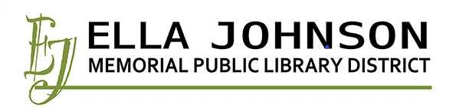
Public Hearing
Monday, August 23, 2021, 6:45 PM
PURPOSE: Tentative Budget and Appropriations for Ordinance 2021-08-01 Combined Annual Budget and Appropriations for
Fiscal Year July 1, 2021 – June 30, 2022

AGENDA:
- Call to Order
- Public Comment
- Adjournment

